First Love – Utada Hikaru

Introduction
In this blog, I’m going to be writing about the song First Love by Utada Hikaru, released in 1999. I first heard this song probably sometime around high school and then was re-introduced to it when it was covered by Le Sserafim’s Kim Chaewon (https://www.youtube.com/watch?v=rboiHxBqdZk). Its lyrics are fairly simple, and the general mood is melancholic. However, the combination of Hikaru’s voice, and singing techniques with its blend of Western R&B with simple strings and piano created a truly groundbreaking piece of music. It defined a new era of J-pop and is still popular decades later.

Background
Prior to releasing her debut album, First Love, Utada had already been working as a musician since the age of 12. However, her early works did not see much success. A year before releasing First Love, she had released an English R&B album that also failed to gain traction. The album failed to release in the States at the time, but it did manage to catch the attention of a producer in Japan; this gave her the opportunity to continue pursuing her musical career there. So Utada decided to move full-time to Japan, leaving her life in New York behind. Her time in New York did however shape her lyricism going forward, as she was able to utilize both English and Japanese in her songs. This gave them a more conversational vibe and usually made them more blunt and raw compared to other Japanese artists at the time, whose lyrics were usually more poetic in nature.
Another aspect of her life that shaped her lyrical maturity was the tumultuous relationship between her parents. It’s well known that her parents divorced multiple times, and this led to Utada growing up in a constant cycle of separation and reconciliation. This would have heavily impacted her views on love which may have led to the bittersweet underlying tones in “First Love,” as well as explain the maturity of the lyrics, given that she wrote the song when she was only 15.

The Song Itself
Since I’m not a native Japanese speaker, I’ve done the breakdown as best I can using translation apps and explanations from AI. I’ll include the English translation beside each line.
Here’s the translation from genius.com https://genius.com/Genius-english-translations-hikaru-utada-first-love-english-translation-lyrics

Verse 1
Saigo no kisu wa Our last kiss
Tabako no kuni ga shita Tasted like cigarettes
Nigakute setsunai kaori A bitter and painful scent
In the first verse, she sets the bittersweet mood by evoking a memory of a last kiss and the lingering scents and taste that accompany it. In Japanese culture, scent and taste are closely linked to memory. An important element here is the word Setsunai. While it translates to “painful,” it’s meant to portray a heart-constricting, suffocating feeling of helplessness. By linking it with the scent of cigarettes, it’s almost like the memory is choking her, because when people smell cigarettes, it generally evokes the sensation of coughing or a tightness in the chest.

Pre-chorus 1
Ashita no imagoro ni wa By this time tomorrow
Anata wa doko ni iru n darou I wonder where you are
Dare wo omotteru n darou I wonder who you're thinking of
Here in the first pre-chorus, we can see her wondering about the current state of the other person, and if they are in a different place (both emotionally and physically). There’s a sense of anxiety and uncertainty which will contrast with the second pre-chorus.

Chorus
You are always gonna be my love
Itsu ka dare ka to mata koi ni ochite mo Even if I fall in love with someone else someday
I'll remember to love
You taught me how
You are always gonna be the one
Ima wa mada kanashii love song Right now, it’s still a sad love song
Atarashii uta utaeru made Until I can sing a new song
The chorus is where there are the most transitions between English and Japanese. This allows her to express raw emotions without the filtering that exists in Japanese, which is known for its social politeness. Additionally, phrases such as “I love you” are often seen as overly heavy and “cheesy” in Japanese, but saying them in English acts as a buffer to make the declarations lighter and more modern.
The chorus conveys how her first love will always hold that special place regardless of what happens, and the lasting impact they had on her. There is also a sign of hopefulness: even though she is sad right now, there’s hope for her to find something new in the future. In Japanese culture, the concept of “Hatsukoi,” meaning First Love, is seen as something sacred and unrepeatable, which is why it’s considered to have a profound impact on someone’s life. This is why she emphasizes remembering the loss and the lessons she’s learned, treating the heartbreak with purpose rather than viewing it as just a loss.
One notable metaphor in the chorus involves the use of “Song.” In Japanese poetry, “singing a song” is often used as a metaphor for how one lives their life. In a way, she’s saying she’s currently stuck in this sad version of herself, until she can find a new chapter.

Verse 2
Tachidomaru jikan ga The time that has stopped
Ugokidasou to shite iru Is trying to start moving again
Wasuretakunai koto bakari There are only things I don't want to forget
This verse, following the chorus, carries a connotation of moving on and finding a new chapter. Within the context of Utada herself, this could symbolize her moving from New York to Japan and the transition she’s experiencing. Ugokidasou, meaning time starting to move, often implies a change in environment or a fresh start. While she is physically moving on, there are things, memories, that she is mentally fighting to keep “stopped” in place.

Pre-chorus 2
Ashita no imagoro ni wa | By this time tomorrow
Watashi wa kitto naite iru | I will surely be crying
Anata wo omotte iru darou | I’ll probably be thinking of you
In the second pre-chorus, we can see that the focus has shifted more to first-person. Now it’s a form of introspection, and it becomes clear that she is predicting her own grief. Instead of ambiguous words like Doko (where) and Dare (who), she uses words like Kitto (surely) to convey certainty. The two contrasting pre-choruses help create a sense of time where we go from denial/curiosity to acceptance/despair.
One other interesting detail is the use of the word Darou (I guess/probably). While she uses the word in both pre-choruses, in the first it feels like a genuine question. However, the second use sounds more like a resigned prophecy that she will not be okay because she knows herself.

Bridge
You will always be inside my heart
Itsumo anata dake no basho ga aru kara Because there will always be a place just for you
I hope that I have a place in your heart too
Now and forever you are still the one
Ima wa mada kanashii love song Right now, it’s still a sad love song
Atarashii uta utaeru made Until I can sing a new song
The bridge serves as a turning point in the piece and is intended to provide a different perspective from the preceding verses and chorus. Here she grounds the imagery by creating a physical architecture for her love through the word Basho (place). Moreover, instead of only wallowing in her own despair, she reaches out to the other person hoping that she will have a place in their heart as well, just as she has made one for them.

Chorus 2
You are always gonna be my love
Itsu ka dare ka to mata koi ni ochite mo Even if I fall in love with someone else someday
I'll remember to love
You taught me how
You are always gonna be the one
Mada kanashii love song Still a sad love song
Now and forever...
Chorus 2 is very similar to the first chorus, except the last two lines are different. Instead of saying that she will be singing a sad love song until she sings a new one, it’s now been replaced with “Now and forever”. Repeating this line from the bridge seems to potentially suggest that the First Love and the sad love song are tied together forever and have become inseparable.
Since “Now and forever” immediately follows the line “Still a sad love song”, it could be interpreted as:
- The person will always be the “one” now and forever, which, while sad, is hopeful because it could symbolize her ability to move onward
- The pain from the love has trapped her permanently in the “sad love song” such that now she’s frozen in time and sadness
I think it’s more of the latter, given that earlier in the song the chorus mentions “Until I can sing a new song” but now, revisiting the past, she has dropped the “until” and replaced it with “still”. This creates a moment of resignation. She’s realizing that she won’t be able to find a “new song” because the pain from the first one has left a permanent mark on her.

Photographs
Below are some photographs I took to try to convey the emotions and meanings I gleaned from the song. I also chose to shoot only in JPEG instead of RAW. I wanted to keep things simple and worry-free, just like how first loves are.

Sunset during sunrise

This photo was taken sometime after sunrise, but I wanted to make it look and feel like a sunset. In a way, a first love feels exciting like a sunrise, which leads to the start of a new day and looking forward to what it will bring. The day is filled with endless possibilities, and it seems like we can accomplish anything. Yet when the sun sets, we’re sometimes hit with the realization that we accomplished nothing in the end; all we’re left with is regret and sadness that another day has passed, and we can never get it back. These feelings are like when a first love ends. There’s only regret, sadness, and a realization that it’s gone forever.

Numero Uno Bench

The bench was something I randomly stumbled upon. It was in a park, and I felt it fit perfectly with what I wanted to capture: the words and the lonesome bench. Life is full of little coincidences and often we don’t take enough time to pause or feel gratitude for what we have now, instead always pondering what we could have. Sometimes we should just take a seat and enjoy the moment.

Unbridgeable Finite Distance,


Often, happiness feels like it’s right within our grasp. We reach out wanting to feel the warmth and the safety it provides, but sometimes that last step we want to take seems like an uncrossable distance. This is one of the most prevalent feelings I have when listening to Utada’s song. The relentless struggle of wanting to move on, wanting to reach out, wanting to get back, but ultimately failing to do any of these things. The memories that linger from your First Love are the only reprieve in the absolute darkness that is despair, and we can’t help but turn to them and try to reminisce and find some comfort. However, this is exactly the trap that locks us in an eternal cycle of trying to bridge the unbridgeable gap.

Time has passed

Within Utada’s song, there is a constant cycle of hope and despair, and while trapped in this cycle, it feels like time has stopped moving. And yet, reality is cruel yet merciful. With time, the pain will subside, and we’ll carry on. The constructs we created to trap ourselves will crumble and the sun will rise again. I wanted to capture a bit of that hope within this picture; two people who’ve gone through life’s tribulations but still hold on to each other dearly. They’ve gone through heartbreak, loss, and sorrow but still believe in each other and the hope of tomorrow.

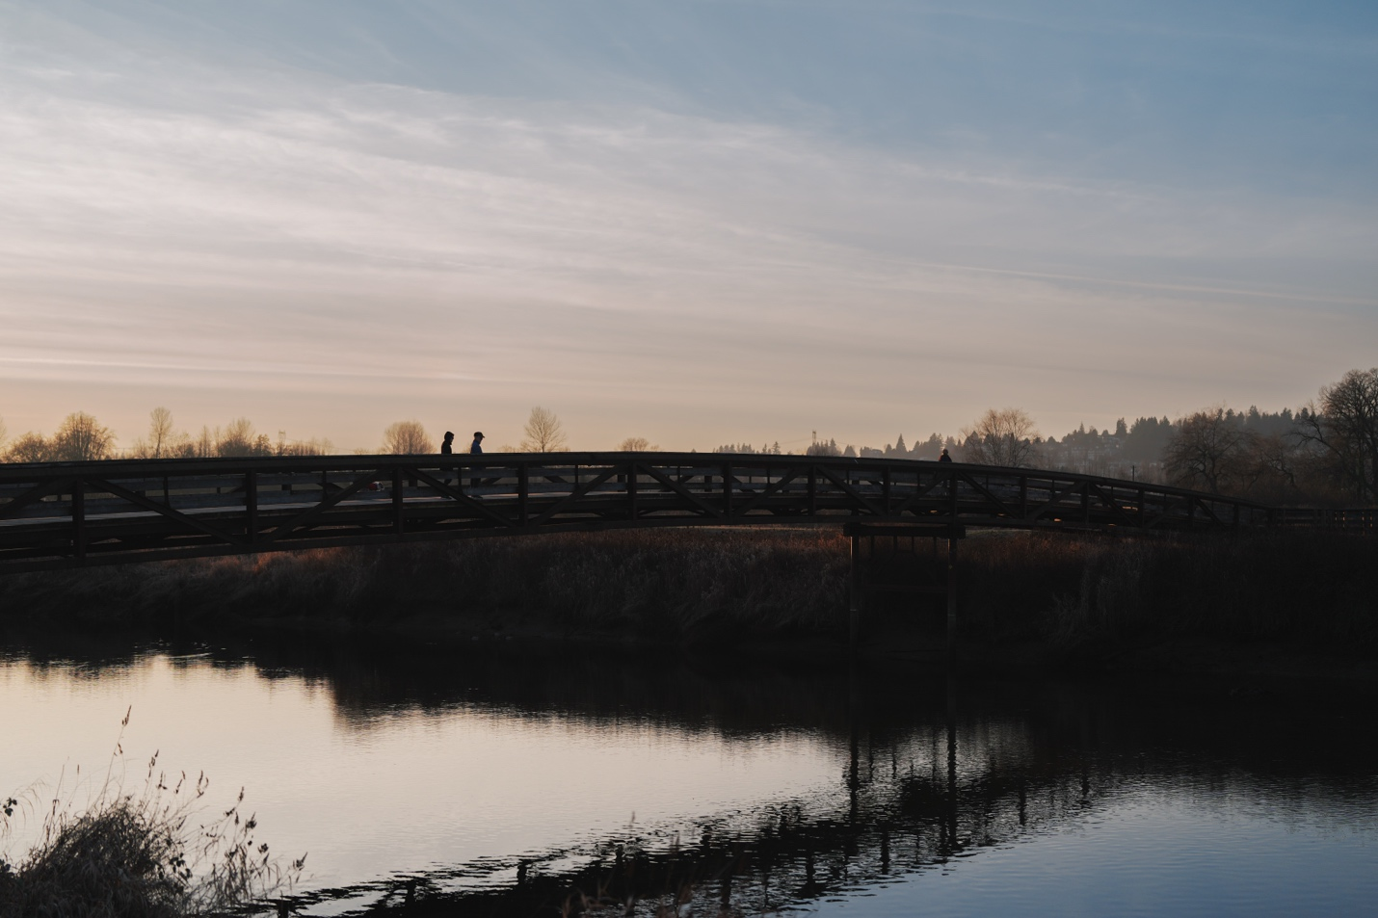
In Japanese culture, the bridge symbolizes the transitional journey from our physical plane to a higher spiritual one. With that in mind, I hoped to capture that transition through our physical life in this picture. The two people are meant to symbolize those who go through life with you. It could be your partner, your friends or even your first love. Then, as life progresses and you reach the end of the bridge, there is only a single person left. That person represents you now at the end of your journey, alone. When it’s your time to step off the bridge, you will do so alone, in totality. Just like Utada said, it’ll be a sad love song, now and forever.

With these photographs, I hoped to capture both the positive and negative emotions I felt from Utada’s song. While the predominant emotions it evokes are regret and longing, it also carries a sense of bittersweetness—which is basically a reflection of life. People go through life piling up regrets, and there’s an ongoing battle between happiness and gloom. We like to reminisce about the good times in the past and fail to live in the now or look to the future. Each of us is trapped in our own thoughts and constructs, trying to always reach for something that feels just beyond our grasp, but may be unattainable. Instead, take a seat on a bench and let the time pass. Slow things down and think about what you have now and what you’re grateful for. Because everything eventually ends, and at the end, there’ll be just one song, the song of your life, now and forever.

